**DAILY ONLINE ACTIVITIES SUMMARY**

|  |  |  |  |  |  |  |  |  |
| --- | --- | --- | --- | --- | --- | --- | --- | --- |
| **Date:** | **21-5-2020** | | | | | **Name:** | **Likhitha.M** | |
| **Sem & Sec** | **6th sem ‘A’** | | | | | **USN:** | **4al17cs046** | |
| **Online Test Summary** | | | | | | | | |
| **Subject** | | **Operating systems** | | | | | | |
| **Max. Marks** | | **30** | | **Score** | | | **30** | |
| **Certification Course Summary** | | | | | | | | |
| **Course** | **Python for machine learning** | | | | | | | |
| **Certificate Provider** | | | **Great learning** | | **Duration** | | | **1 week** |
| **Coding Challenges** | | | | | | | | |
| **Problem Statement:**  **1.**Write C Program to create Singly Liked List with n elements and reverse the elements .  2.Write a C program to construct a singly linked list by removing duplicate elements in the sorted linked list Description: Take a sorted list and traverse the list. Compare the current node element with next adjacent node. If it is same then delete second element, if not retain. Finally print the resulting list. Sample output: Given list {1,2,2,3,3,3,4} Resulting list{1,2,3,4}  **3.Getting a message printed through Applet**  4.Write a Java Program to Demonstrate a Basic Calculator using Applet Problem Description We have to write a program in Java such that it creates a calculator which allows basic operations of addition, subtraction, multiplication and division. Expected Input and Output For creating a calculator, we can have the following different sets of input and output.To Perform Addition : When the addition expression "58+10" is typed, it is expected that the result is displayed as "58+10=68.0". 2. To Perform Subtraction :When the subtraction expression "100.0-28.25" is typed, it is expected that the result is displayed as "100.0-28.25=71.75". 3. To Perform Multiplication :When an multiplication expression "113.6539" is typed,it is expected that the result is displayed as "113.6539=4432.35". 4. To Perform Division : When the denominator is non-zeroWhen an division expression "25126.0/3" is typed, it is expected that the result is displayed as "25126.0/3=8375.33". 5. To Perform Division : When the denominator is zeroWhen an division expression "169.0/0" is typed, it is expected that the error is displayed as "169.0/0=Zero Divison Error". | | | | | | | | |
| **Status:completed** | | | | | | | | |
| **Uploaded the report in Github** | | | | | **yes** | | | |
| **If yes Repository name** | | | | | **https://github.com/likhithaMantaral/Daily-status** | | | |
| **Uploaded the report in slack** | | | | | **yes** | | | |

Online Test Details:

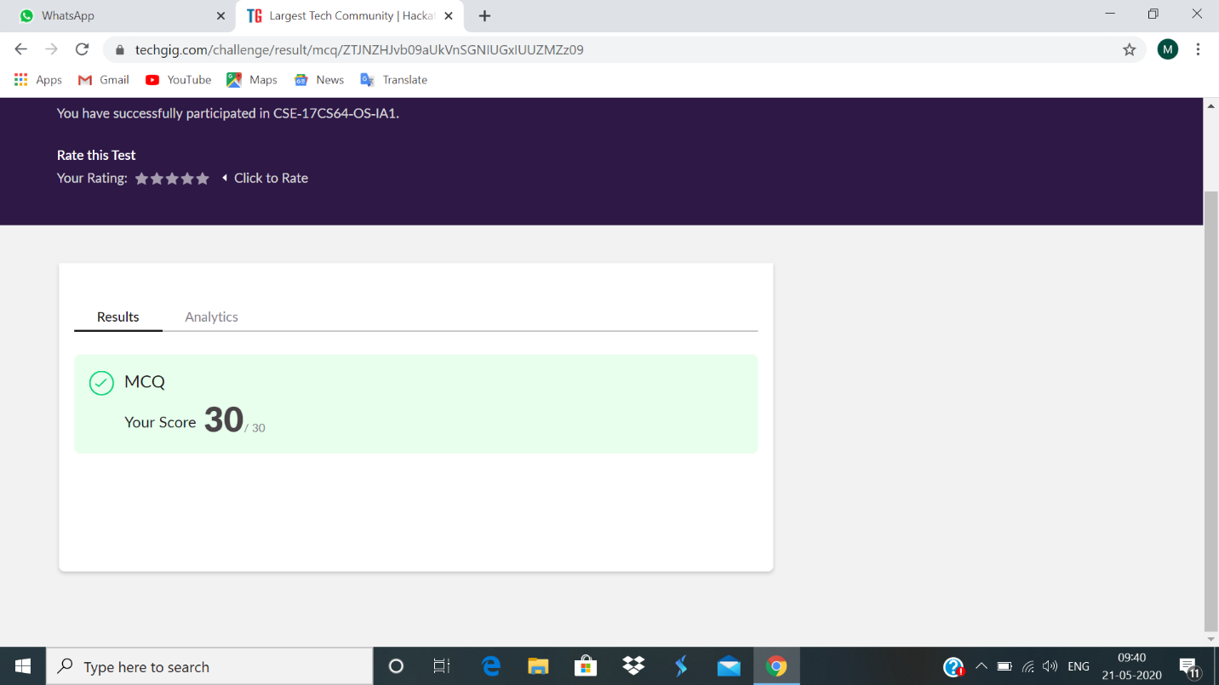

Certification Course Details:

There are some special data types which makes python more dynamic and powerful. Basic data types like int, float, string cannot store multiple values in single variable. For that in python we have ’List’. A list can store sequence of objects, the objects can be of various types. To make a list square brackets ‘[ ]’ are used. Lists can be indexed in the same way as strings. For adding the single value. into list we use Append. Python has a function sorted( ) which can sort the elements in the list. An object can be removed from list by using del( ), remove(), pop() functions. Lists are mutable, tuple are immutable. A tuple cannot be Appended to or extended anyway. Tuples are indexed similar to list. Executed some simple codes.



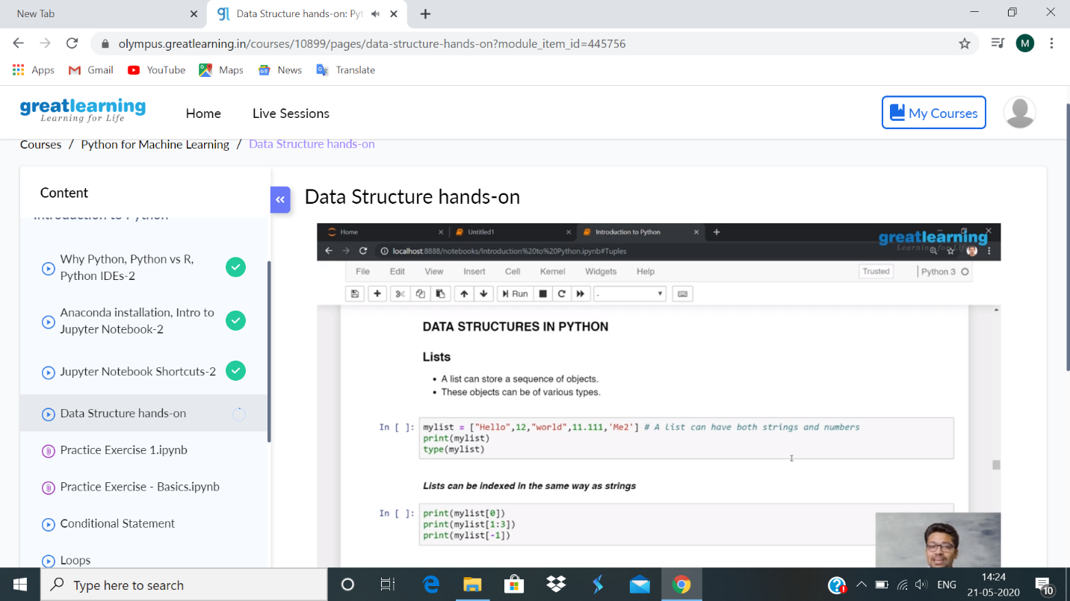

Coding Challenges Details:

1.

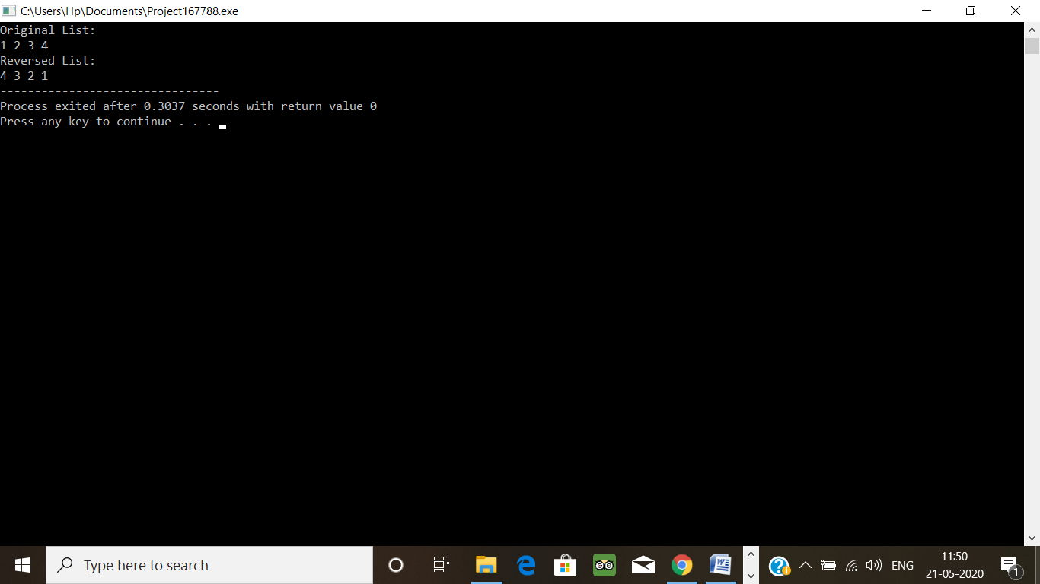

2.

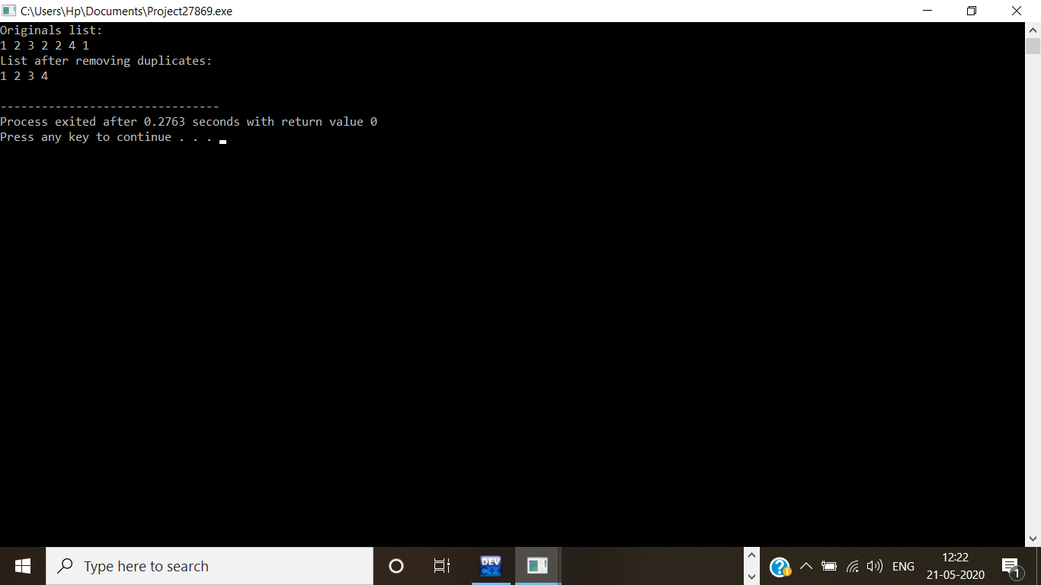  
4.

